ERP Implementation in Cisco
Name
Professor
MGT 608– Information and Supply Chain Systems
Institution
Date

ERP Implementation in Cisco
Summary
Cisco Systems, Inc., the world’s top computer network gear maker, was founded by Leonard Bosack, and Sandy Lerner of Stanford University, in December 1984, in San Jose, California. Although many companies are developing and selling dedicated network nodes by the time Cisco entered the market, it was definitely one of the very few to sell commercially successful routers supporting multiple network protocols. The flexible IOS operating software, coupled with CPU-architecture helped Cisco in keeping up with the evolving technologies, just by making the necessary software upgrades frequently. From day one, Cisco has been very careful in designing and implementing an efficient network of Supply Chain, which enabled to keep the customers, partners, suppliers and the manufacturers stay interacted with each other all the time. Cisco’s top priority is on time delivery under any circumstances, to its customers, and this network was one of the main reasons Cisco was able to achieve that. Whenever Cisco has witnessed troubles with its supply chain network, it made sure to make necessary changes and come up with new developments and upgraded models like CCO, and ICS. Though Cisco has always managed to maintain an efficient Supply Chain network, it made some serious misjudgments which lead to a financial disaster in the early 2000. The purpose of this paper is to analyze why and how Cisco got into trouble, and how Cisco has successfully managed to implement an incredible ERP system within a time of just nine months. This paper also provides a short summary of Cisco’s history, SWOT analysis, and how Cisco managed to deploy the changes with minimal disruption to its customers.

Introduction
With the growth in internet usage in 1990, there has been a dramatic increase in demand for the products Cisco manufactures. By 1993, the company has reached the U.S. $500 million mark. In 1988, CEO John Morgridge made it his first mission to build a management team that is highly professional and follows extremely disciplined structure. By 1997, Cisco managed to be one among the five top companies in ROR and ROA. (Avimanyu, 2009).
Cisco has become a pioneer in its market, with a current revenue of U.S. $11.9 Billion and a huge employee count of 70,112. Current CEO is Chuck Robbins. The company’s name Cisco is taken from San Francisco, and the company’s logo is depiction of the Golden Gate Bridge’s two towers. Over the years, Cisco has acquired various companies in-order to incorporate new products and bring distinct talent into the organization. Cisco has nearly 70,000 channel partners, and is doing business in more than 165 countries. Cisco ranks either number one or two in most of the market segments they serve. (“Overview”, 2014).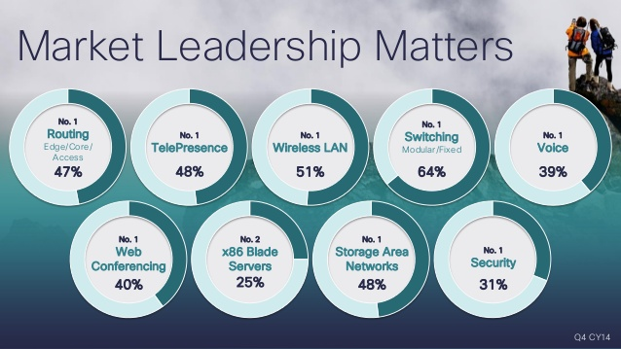
Figure 1 Cisco Market Leadership in various sectors (http://newsroom.cisco.com/overview)
Cisco has always been known for its innovations and this is the reason it has been a trendsetter and leader since the beginning. The following table summarizes Cisco’s innovations from 1984 to 2014. (“Overview”, 2014).
Year | Innovation
1986 | 1st multi-protocol router, the Advanced Gateway Server
1989 | Border Gateway Protocol (BGP) for service providers
1992 | Groundbreaking interior Gateway Routing Protocol Patent
1994 | 1st major supplier of multiprotocol products awarded ISO 9001 cert.
1998 | 1st small office/home/ telecommunicating cable modem
1999 | IP Telephony patent
2004 | Cisco Carrier Routing System (CRS-1)
2006 | TelePresence
2008 | Collaboration Portfolio
2009 | UCS
2011 | ASR 9000 series (1st Terabit-router)
2013 | Network Convergence System (Planet’s fastest router)
2014 | Application-Centric Infrastructure

Table 1 : Cisco's Innovations (http://newsroom.cisco.com/overview)
Cisco ranks 70 among the Fortune’s “100 best companies to work for”, 2015. (“100 best companies”, 2015). Despite the legacy and many successes, Cisco has its own share of controversies and lawsuits such as investigation for Tax fraud in Brazil, 2007, Antitrust Lawsuit filed by Multiven in December, 2008, and Spherix Patent Suit in March, 2014. (“Cisco Systems”, 2015).
Cisco SWOT Analysis
Strengths
Compared to the competitors, Cisco has an immense range of distinct operating segments, which enables it to earn a fairly diversified revenue. International markets generates almost half of Cisco’s current net revenues and the organization continues its expansion into prospective markets. It’s acquisition of Starnet Networks and Tandberg in 2009, enabled it in offering better mobility and video for the communication network. (“Acquisition Summary”, 2009). Cisco ranks either number one or two in almost all the operating segments, hence proving its dominance in advanced technology over and over. Cisco’s place among Fortune’s “100 companies to work for”, helps it in attracting and retaining qualified personnel. (“100 best companies”, 2015). One of the other strengths is its highly efficient network of supply chain management. Cisco’s attention to detail and quality is what helps them to earn loyal customers.
Weaknesses
Cisco’s huge inventory level costs them a sizable amount on inventory management. Poor inventory management landed Cisco in a financial disaster in the early 2001. (Mukund, Subhadra, 2002). Cisco is always known for its innovations, but that does come with high investment in the R&D segment, which sometimes not yield favorable outcomes. Cisco outsources many of their business processes, making it very hard to keep control over the quality. On the other hand, Cisco manufactures high quality products, which makes them price their products higher. It’s often very hard to estimate demand for its products, and this leads to shortage or surplus production. Cisco’s business depends on the assumption of continual growth of technology and this may or may not be always true. Even a little lag in this sector effects the company.
Opportunities
A few of Cisco’s threats can be channeled into its opportunities. The huge investments in R&D is what leads them in making new products, and innovations, which makes Cisco an industrial leader. The Asian market is massive and a gigantic raise in their internet spending proves to be a great opportunity to Cisco. Cisco’s acquisitions and partners provide it the opportunity to emerge in diversified markets, hence opening the doors to unlimited opportunities and new markets. The advancement of technology promises Cisco a lot of opportunities. Cisco has embraced market trends and partnered accordingly to seize the massive opportunity like cloud technology. (Bruce, 2014).
Threats
China’s TOR switches, which are inexpensive when compared to Cisco’s, are likely to be a huge threat. While Cisco has proved to be a dominant market leader, there are actually a few competitors that pose a serious threat to Cisco. Companies like Riverbed, Juniper, Polycom, Brocade, HP and Avaya have thrived in the recent years and proved to be a tough competition to Cisco. (Zeus, 2013). Cisco has gone through some rough patch, during the first dip in the economy and, if anything like that happens again, Cisco is going to be greatly affected, since its financial performance depends highly on market conditions.
Cisco’s Supply Chain Network
Since the company has been established, Cisco has made it its priority to have an efficient network that brings together the customers, employees, suppliers and manufacturers together, which in-turn helps Cisco to deliver products of high quality in time. The company’s legacy IT infrastructure was internally oriented and mostly traditional. It used the software package which is UNIX-based to conduct the core tasks of transaction processing.
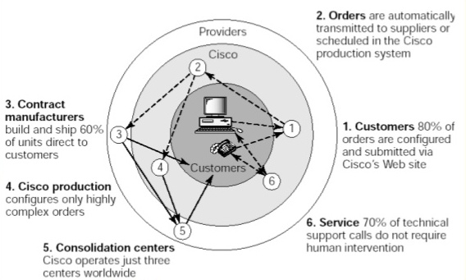
Figure 2: Cisco Value network

Need for ERP
With the growth in the business, it started becoming incredibly hard for Cisco to manage with the available software package. According to then Cisco’s CIO, Pete Solvik’s analysis, the UNIX-based software failed in providing the degree of reliability, redundancy and maintainability that was needed to keep pace with their increasing business demands. An upgrade of the software was provided, which was more reliable and redundant, but could not meet the maintainability factor. In 1993, every business unit in Cisco was supposed to make their own decisions regarding their IT systems, and failed to notice the need of a common database and architecture. In January, 1994, the legacy environment of Cisco had entirely failed, leading to the company’s shut down for nearly 2 days. It was then the management decided to adapt and implement the ERP architecture, which binds all the functional units in an organization into a single unit. (Avimanyu, 2009).

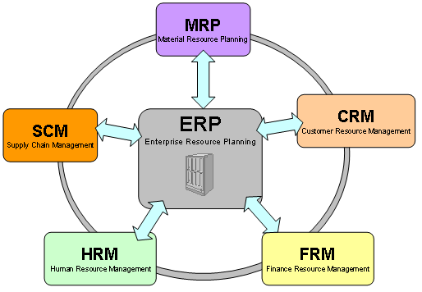
Figure 3: Enterprise Resource Planning (ERP) architecture

Challenges
The Management team at Cisco were faced with quite a few challenges in this process.
- Selecting an efficient partnering consultant and ERP vendor.
- Finalizing the budget and setting up a schedule.
- Organizing and managing the ERP implementation team.
Cisco found that KPMG was the only one consulting partner that is compatible with its needs, since they agreed to provide services from stage one of selecting an efficient vendor till the stage of projection completion. After an extensive market research, oracle had been chosen as their vendor. This decision proved to be a motivation to oracle, since this would be their first chance to implement their new ERP product in such a huge scale. The management of Cisco were worried about the massive amount of cost, time and resources a project of this scale could potentially consume. The team finally decided on a budget of U.S. $15 million and a time period of 9 months. A team of 100 members, the best people across all the business units, were put on this project. (Avimanyu, 2009).
Implementation
The team members were divided into five modules, each group related to one functional area - Order entry, Finance, Manufacturing, Technology, and sales/reporting. Cisco chose to employ the development technique of “rapid iterative prototyping” to implement the ERP. Since oracle was new in market and Cisco was their major client, oracle customized the coding according to Cisco’s requirements.
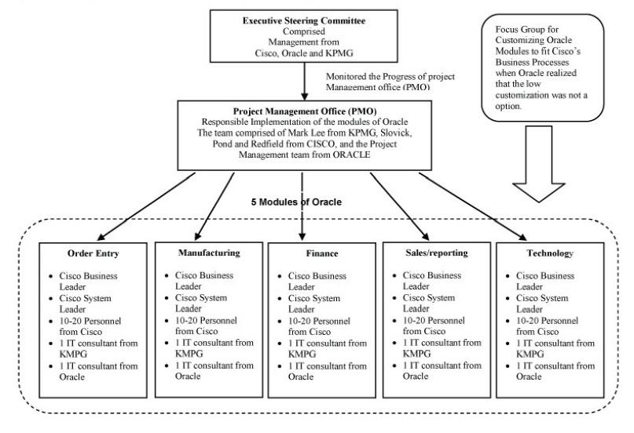
Figure 4: Organizational structure of ERP implementation
The entire process of implementation was divided into a series of stages called “conference room pilots” (CRPs). During the first stage, that is CRP0, Cisco’s employees were trained on Oracle Packages, 80% of the requirements were stated, and the necessary data settings to be embedded into the Oracle software with respect to Cisco’s business needs were selected. After the successful delivery of the prototype, the implementation process reached to the second stage, CRP1. This stage was built on CRP0, and is targeted on making the software work within the specific area of the five modules. CRP2 concentrated on enhancements, perfection and testing. (Avimanyu, 2009)

Hardware changes and Stabilization
On beginning operation, the system was highly unstable. The key problem was the architecture of hardware, and the other problem was the inability of the software to handle high volume transactions. Oracle made the necessary changes to the software, and Cisco corrected the inefficient hardware. The combination of KPMG’s experienced support, Oracle’s strong commitment led to the successful development and application of ERP.
Reasons for Success
Success of Cisco in this project can be attributed to three factors: key timing, hard work and luck. The period when Cisco decided to implement ERP was in sync with the period when Oracle needed an opportunity to launch, test, and to perfect the modules with necessary corrections. Oracle found an opportunity through Cisco to prove itself in the market. This timing placed Oracle and Cisco in the same boat, which led them in helping each other to succeed. Oracle provided Cisco with customized modules which no other vendor was ready to provide, and Cisco provided marketing assistance and promoted upcoming Oracle’s products and ERP. Cisco, KPMG, and Oracle put their best resources together and successfully finished the project within the estimated budget and on-time. The procedure followed by Oracle and Cisco confirmed Kwon and Zmud’s (1987) six-stage sequential model for IT implementation, which are - initiation, adoption, adaptation, acceptance, routinization, and infusion. (Kristina, 2005).

Conclusion
Cisco’s leaders’ vision, capability to take bold decisions when necessary and in-time, and adapting to the necessary changes in technology helped them to be a leader in their field. Cisco never considered its investments in IT as sunk cost. With its innovations, and advanced technology, Cisco always managed to grab majority of the market share in all its business units. With all the right planning, investments, acquisitions and partnerships, Cisco has grabbed and utilized all the opportunities to its best. Cisco restructured itself from time to time and succeeded in overcoming any global economic impacts. Cisco has a promising future ahead because of the advancement in the technology, as Cisco has decided to focus on the current evolving technology, cloud technology. (“Cisco Systems”, 2015).

References
Acquisition Summary. (2009). Retrieved from http://www.cisco.com/web/about/doing_business/corporate_development/acquisitions/ac_year/about_cisco_acquisition_years_list.html
Avimanyu, D. (2009). Cisco Systems: Implementing “Customized” ERP in Nine Months and within Budget. Washington State University, USA. Retrieved from http://go.galegroup.com.ezproxy.nu.edu/ps/i.do?ty=as&v=2.1&u=nu_main&it=search&sv =RELEVANCE&p=AONE&qt=SP~56~~IU~2~~SN~1548-7717~~VO~11&lm=DA~120090000&sw=w&authCount=1
Bruce, K. (2014). Cisco Blogs. Cisco Partner Ecosystem. Retrieved from http://blogs.cisco.com/news/cisco-partner-ecosystem
Cisco Systems. (2015). Retrieved from https://en.wikipedia.org/wiki/Cisco_Systems
Kristina, S. (2005, May). Information Technology Implementation: What Works and what does not. Graduate School of Vanderbilt University, Tennesse. Retrieved from http://etd.library.vanderbilt.edu/available/etd-04012005-210048/unrestricted/statnikova.pdf
Mukund, A., & Subhadra, K. (2002). Cisco Systems: The Supply Chain Story. ICFAI center for Management Research, India. Retrieved from http://www.icmrindia.org/free%20resources/casestudies/cisco-supply-chain-1.htm
Overview. (2014). Retrieved from http://newsroom.cisco.com/overview
Zeus, K. (2013, July). Network World. 10 Competitors Cisco Couldn’t Kill Off. Retrieved from http://www.networkworld.com/article/2290577/data-center/111748-10-competitors-Cisco-couldn-t-kill-off.html#slide2
100 Best Companies to Work For. (2015). Retrieved from http://fortune.com/best-companies/

